

compiler construction

GROUP ASSIGNMENT 1



# **GROUP MEMBERS**

|  |  |
| --- | --- |
| *NAME* | *REGISTRATION NUMBER* |
| **YVONNE KIMANI** | SCT212-0475/2017 |
| **MARK MUNENE** | SCT 212-0224-2017 |
| **GABRIEL WAINAINA MWANGI** | SCT212-0480/2017 |
| **IAN MWANGI** | SCT212-0066/2017 |
| **STANLEY NGUGI** | SCT212-0065/2017 |
| **DENNIS GACHOMO** | SCT212-9218/2015 |

1. **Write a LEX specification files to:**
   1. **Count the number of words in a file and their total size**

*Solution*

%{

#include <stdio.h>

int words=0, c_letters=0, total=0;

%}

%%

\n {words++;}

[\t ' '] words++;

[a-zA-Z] c_letters++;

%%

int main(){

yyin=fopen("sample.txt","r");

yylex();

total = c_letters+words;

printf("File Contents...\n");

printf("\n\t%d Words",words);

printf("\n\t%d Text Characters",c_letters);

printf("\n\t%d Total Characters\n",total);

return 0;

}

int yywrap(){

return 1;

}

*Result*

Sample Text File Contents:

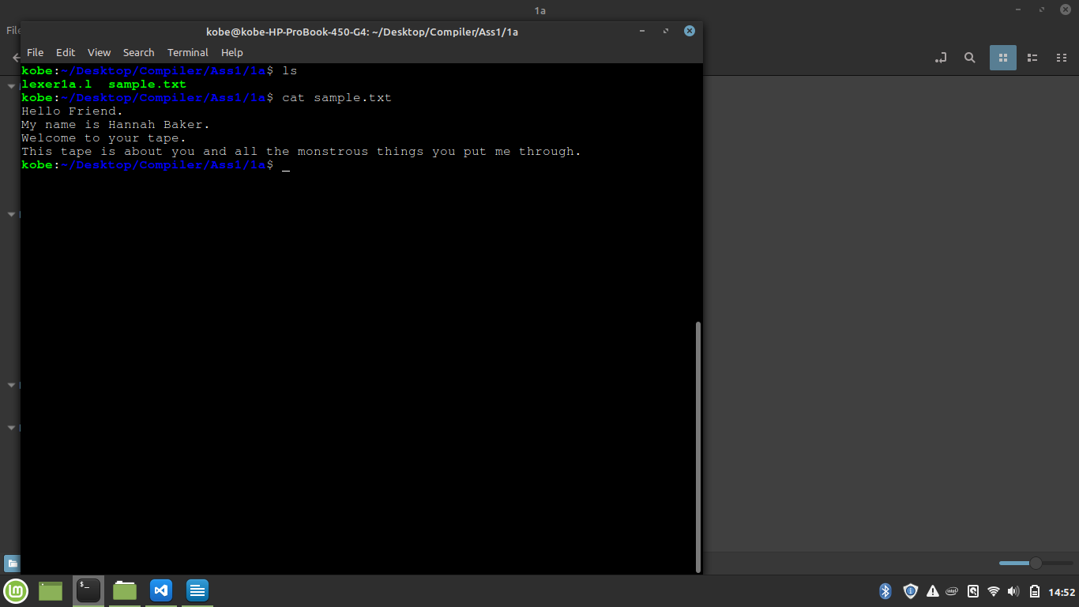

Sample Output

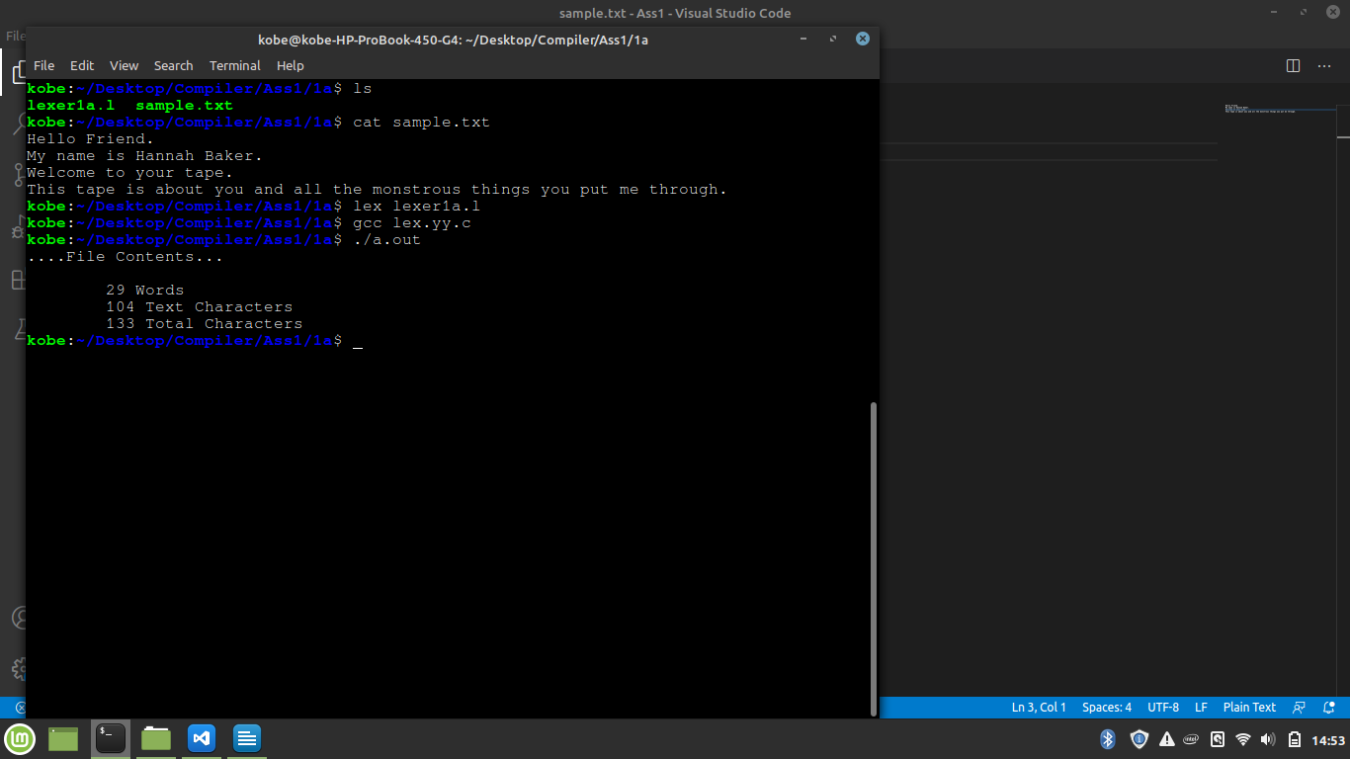

* 1. **Counts the number of different words in an input**

*Solution*

*%{*

*int words = 0; // will be counter for our different words*

*char *cache = NULL; // the unique words will be put in the 'cache' variable*

*%}*

*%%*

*[a-zA-Z0-9]+ {*

*int ret_code = 0; //retrival code: code to check if input matches regular expression*

*char *target = NULL;*

*char *found = NULL;*

*// add a 'space' before and after the word for words matching and word boundaries.*

*ret_code = asprintf(&target, " %s ", yytext);*

*if (ret_code < 0) {//returns No<0 if input does not match reg exp*

*exit(1);*

*}*

*// check for NULL in cache var*

*if (NULL != cache) {*

*found = strstr(cache, target); //checks for first occurence of a word*

*}*

*// if the word has NOT been found*

*if (NULL == found) {*

*words++;*

*// store this new different word into the cache*

*ret_code = asprintf(&cache, "%s%s", cache, target);*

*if (ret_code < 0) {*

*exit(1);*

*}*

*}*

*}*

*. ; //ignore other words not defined above*

*%%*

*int main(int argc, char **argv) {*

*yyin = fopen("input.txt", "r"); //open and read input file*

*yylex(); //opening and reading input stream*

*printf("\nDifferent words are: %d\n", words);*

*return 0;*

*}*

*int yywrap() { return(1); } //shows end of input*

*Result*

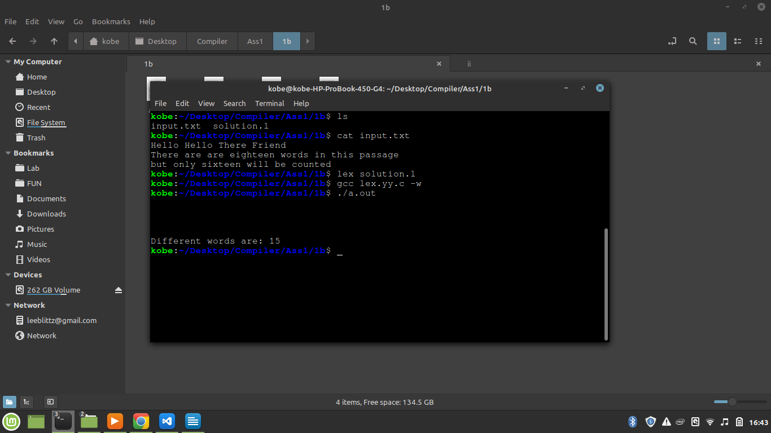

* 1. **Accepts the English language words (without bothering for the meaning) and replaces each occurrence of the string “abc” in it to “ABC”.**

*Solution*

%{

#include<stdio.h>

#include<string.h>

int i;

%}

%%

[a-zA-Z]* {

for(i=0;i<=yyleng;i++)

{

if((yytext[i]=='a')&&(yytext[i+1]=='b')&&(yytext[i+2]=='c'))

{

yytext[i]='A';

yytext[i+1]='B';

yytext[i+2]='C';

}

}

printf("%s",yytext);

}

.* {ECHO;}

\n {printf("%s",yytext);}

%%

int main()

{

yylex();

return 0;

}

int yywrap()

{

return 1;

}

*Result*

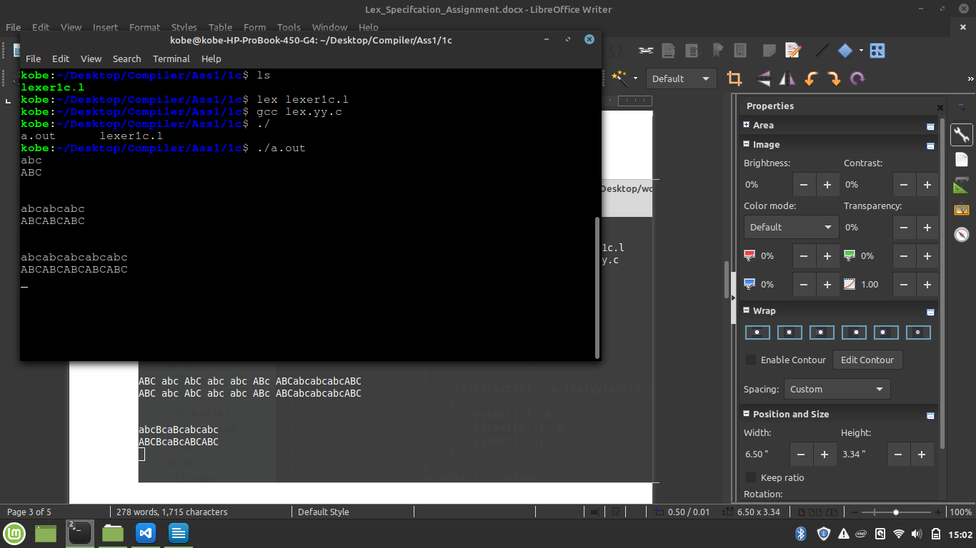

1. **The following is a listing of a set of verbs:**

*is am are were*

*was be being been*

*do does did will*

*would should can could*

*has have had go*

**Write a simple LEX specification to recognize these verbs**

*Solution*

%{

#include <stdio.h>

%}

%%

[\t ' ']+ /* ignore whitespace */ ;

is |

am |

are |

were |

was |

be |

being |

been |

do |

does |

did |

will |

would |

should |

can |

could |

has |

have |

had |

go { printf("%s: is a verb\n", yytext); }

[a-zA-Z]+ { printf("%s: is not a verb\n", yytext); }

.|\n { ECHO; /* normal default anyway */ }

%%

int main()

{

yylex() ;

return 0;

}

int yywrap(){

return 1;

}

*Result*

